**[Accounting services](https://accuretax.com.au/)**

* Accure Tax provides [**Accounting services**](https://accuretax.com.au/)**,** [**mobile tax professional services in brisbane**](https://accuretax.com.au/tax-experts-company-about-us/)**.**
* We offer individual tax returns. Whether your return is simple or complex with sole trader business  
  or a contractor we have you covered.
* We Also Offer tax accountants gold coast ,tax experts company ,tax accountants ormeau hills ,accounting services, help with tax planning
* Diiferent types of services such as accountants & tax agents ,[**tax experts company queensland**](https://accuretax.com.au/tax-experts-company-about-us/), tax experts ormeau hills, mobile tax professional services in brisbane, tax compliance experts

[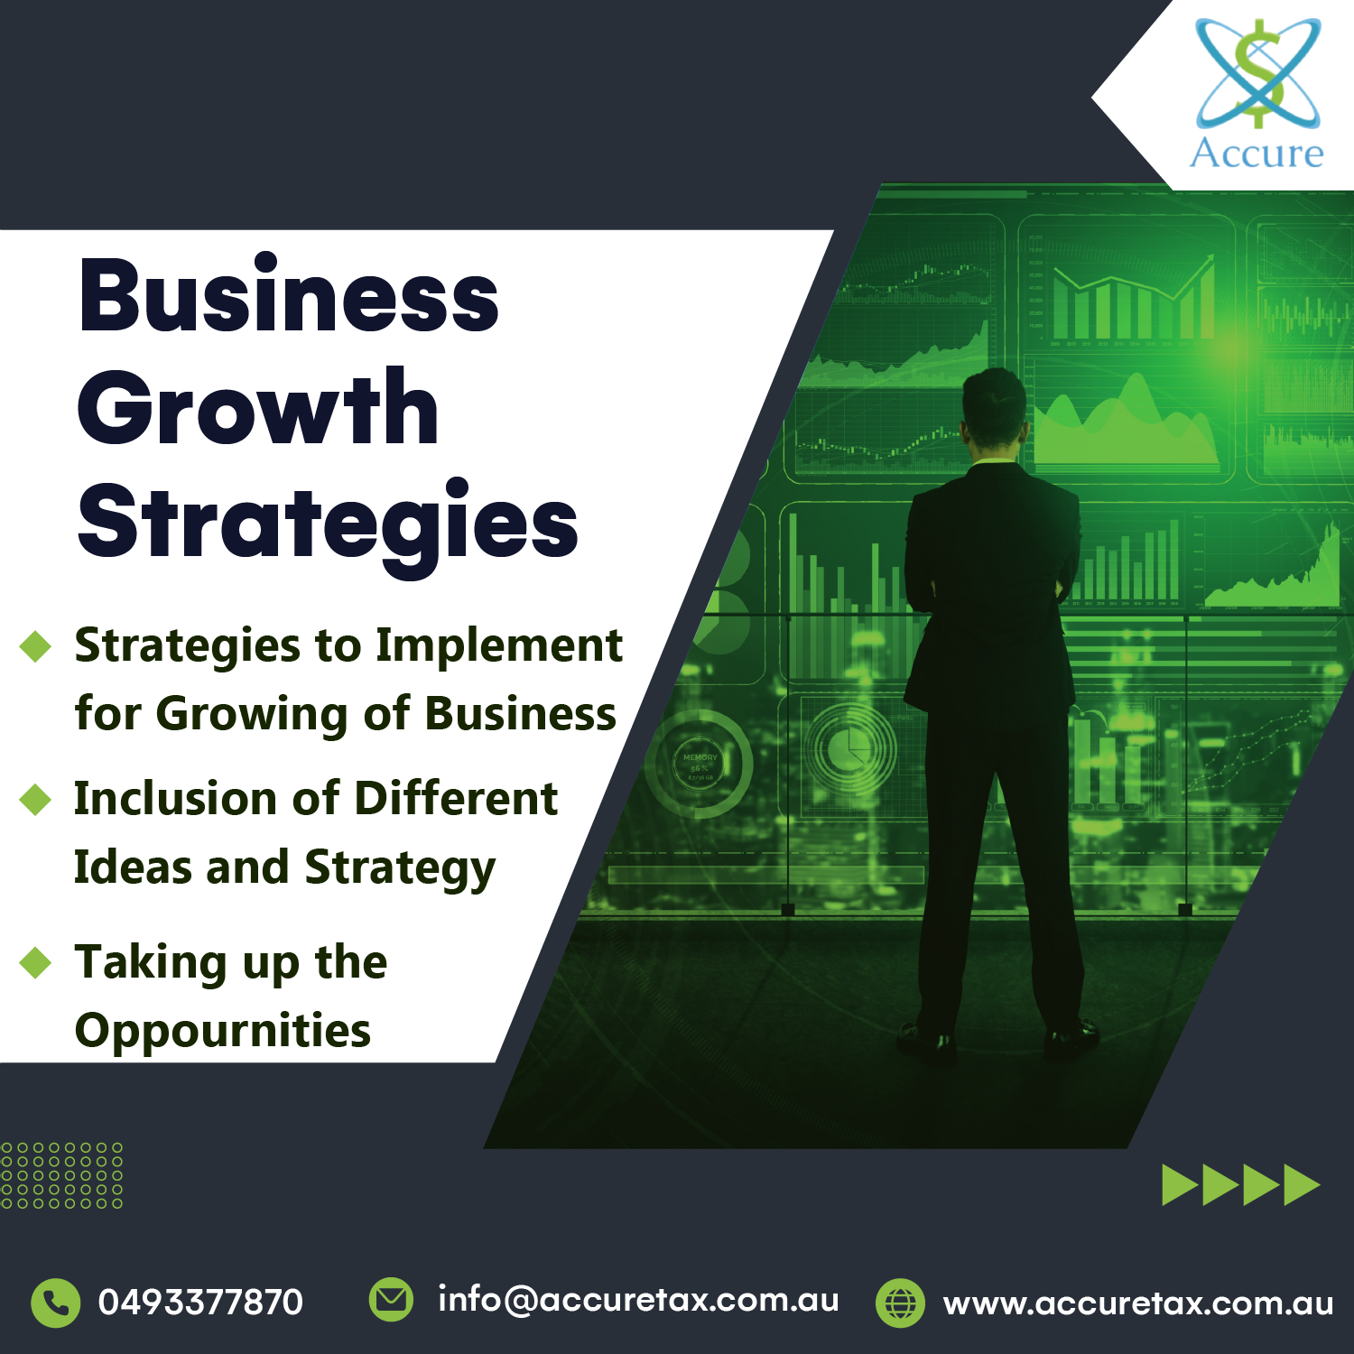](https://accuretax.com.au)

We are here to provide expert tax accountants,tax return queensland [**,tax solution company queensland**](https://accuretax.com.au/accounting-services-contact-us/) ,bookkeeping solutions